REGULAR GIVING TO THE MARK BENEVOLENT FUND
A regular gift is a convenient way to pay. If you wish to pay by this method, please complete the form below to notify us of your gift and then send to your bank the attached “Bank Standing Order Mandate”. You must write your MMH Membership Number as a Reference. This can be found on your Grand Lodge Certificate, Annual Return or you can telephone us at Mark Masons’ Hall.
Name:
Address:
Postcode:
Lodge Name & No:
MMH Membership No: | Date:

I pledge £............ per month* / quarter* / year * for a period of................ years.
*delete as appropriate
I wish the contribution to commence on (date) ……...... / ........... / 20......
I would like all payments to be credited to the ‘2035 Derbyshire Mark Festival’

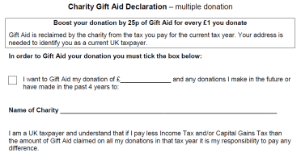

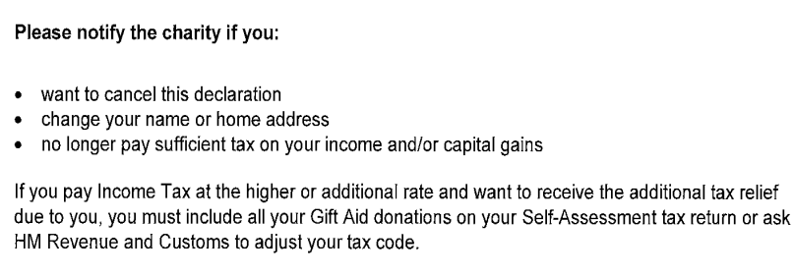



Signature: ........................................................... Date: ...............................

Bank Standing Order Mandate Please send this section to your Bank
Name and Address of Your Bank | Account Number | Sort Code
Please pay to: The Mark Benevolent Fund No 1 Account
Name and Address of Bank | Account Number | Sort Code
Clydesdale Bank PLC | 60225892 | 82-12-08
7 Gold Street, Northampton
NN1 1EN

Reference: MMH Membership No: (mandatory)

The sum of £......... to commence on (date) ……...... / ........... / 20......
and monthly* / quarterly* / yearly * thereafter until further notice
*delete as appropriate
or end date of ……..... / ........... / 20......
Signature: | Address:
Name:
Date:

PLEASE ASK YOUR BANK TO USE YOUR NAME AND MMH MEMBERSHIP NUMBER AS A REFERENCE OTHERWISE YOUR DONATION MAY NOT BE CREDITED TO YOUR ACCOUNT

